1. **"Lexical Analyzer"**

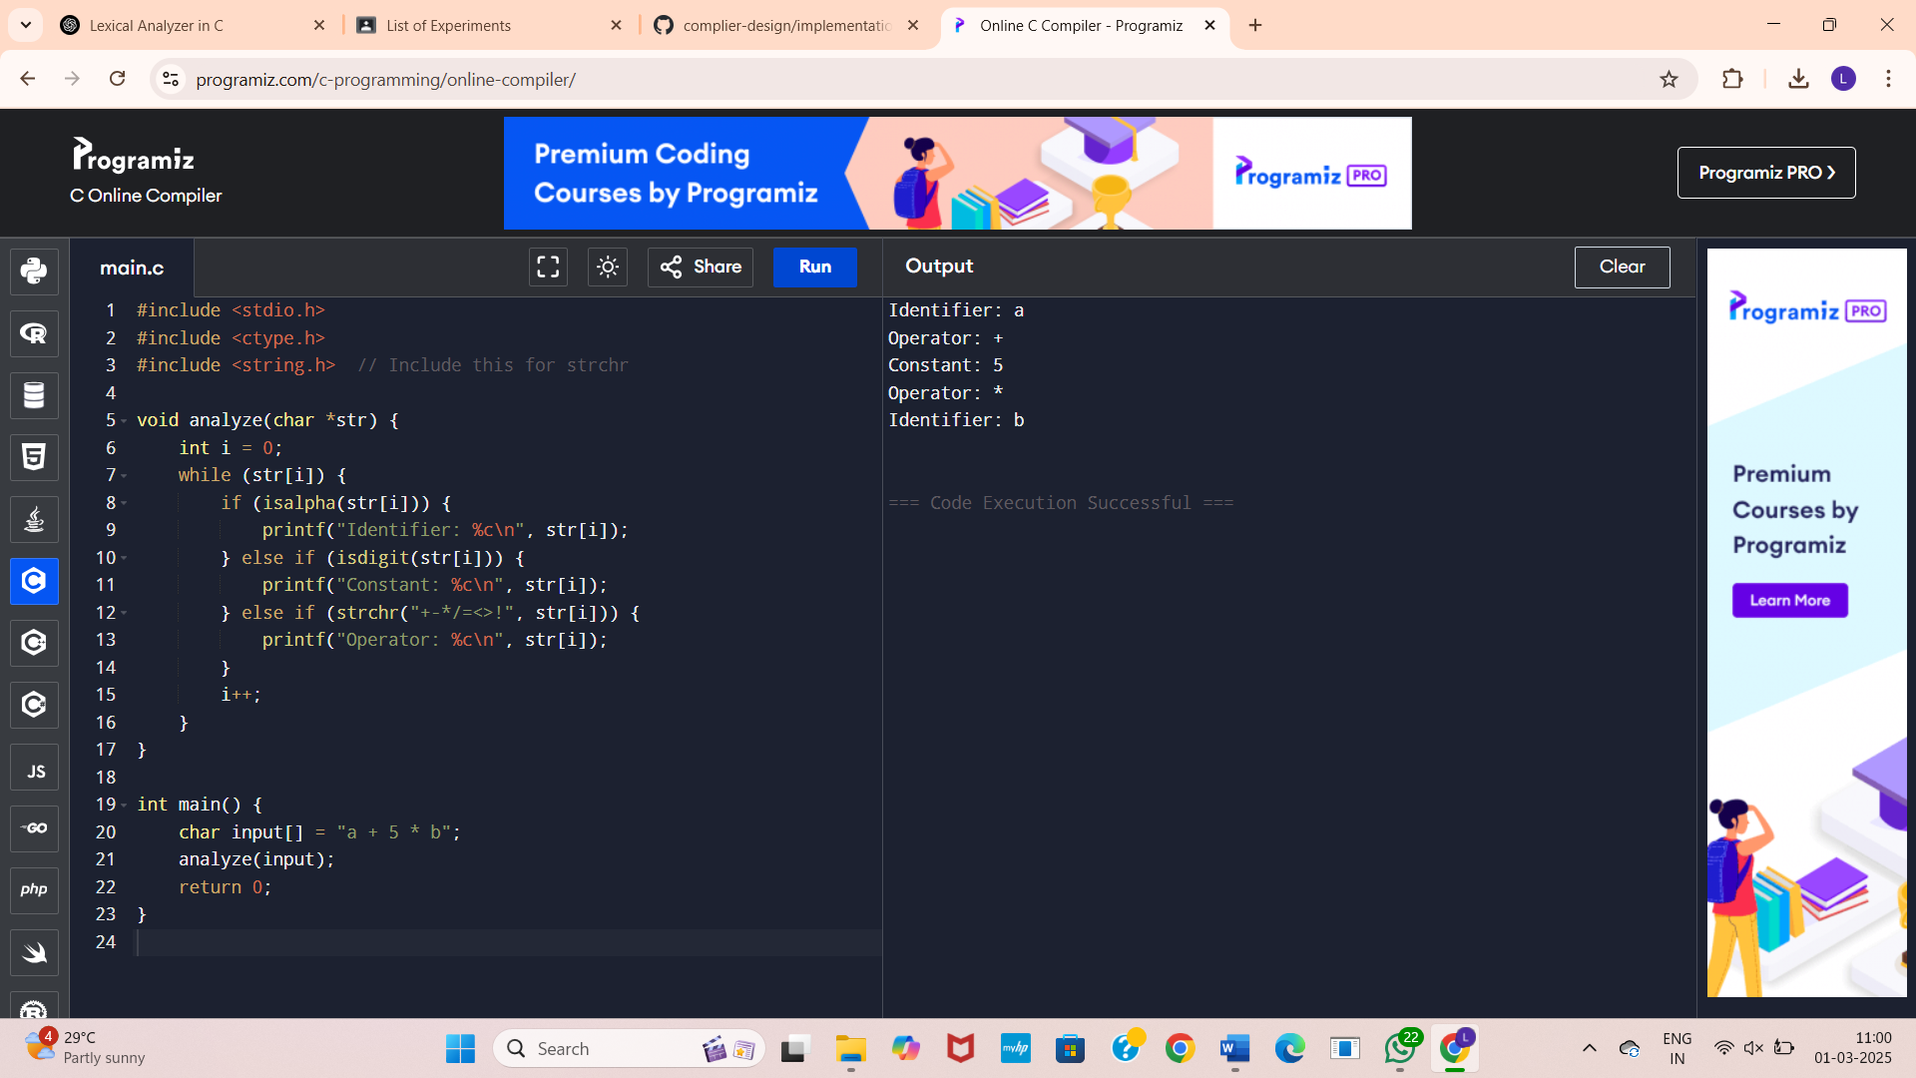

2. Simple Lexical Analyzer

